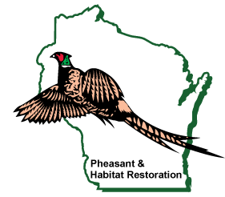

Wings Over Wisconsin

Coulee Region Chapter

31st Annual Banquet
Monday March 9th, 2026
Holmen American Legion, Holmen, WI
Doors Open at 5:30 pm, Dinner at 7:00 pm

**************************************************************************************************
(Please make a copy or remove and include with payment)

I would like _____ Dinner Tickets at $75.00 each Total $________

$200.00 Individual Sponsorship
(Banquet/Diner ticket, Sponsor Gift, entry into Sponsor Gun Drawing, No wings bucks) Total $________

I am not able to attend the banquet but still want my annual membership $30.00 Total $________

Presale Banquet Wings Bucks Quantity ____
$170.00 for $100.00 Total $________

We are looking for new members on our board as we our current members are getting older and stepping back. If you are interested in working projects, fundraising, and education please check below.

I am interested in joining the Wings Board and continuing the chapter into the future
TOTAL ENCLOSED $_________
Registration includes Membership, newsletter, Dinner, and door prizes (as drawn while supplies last)
Register early and no later than February 20th to ensure ticket availability

Name _________________________________________________________________

Address________________________________________________________________

City___________________________________State_________Zip___________

Optional Telephone No.______________ email address_____________________________
Please mail a self-addressed stamp envelope with form, and check to:
Coulee Region Wings Over Wisconsin c/o Cindy Conger
W5409 County Rd D
Holmen, WI 54636
Any questions please contact Cindy Conger 608-780-0147

